
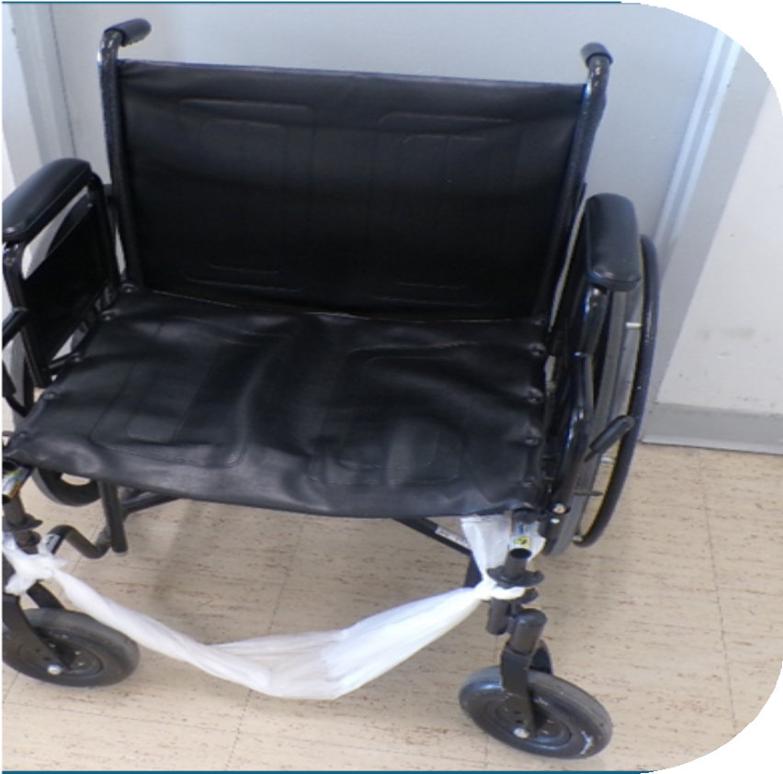


INVESTIGA TIO N

Deliberate Indifference:
Systemic ADA Violations and Endangerment of Wheelchair Users at Women’s Huron Valley Correctional Facility

February 2026


Americans with Disabilities Act (ADA) violations at Michigan's only women's prison.

01
Executive Summary

03
Background
Table of Contents

05
Methodology

07
Findings

18
Personal Testimony

21
Recommendations

22
Conclusion

23
Appendix

Women with disabilities are, on average, missing half of their meals and over 75% of critical medication doses due to an inadequate supply of functioning wheelchairs and aides.
Disability Rights Michigan (DRM), the federally mandated Protection and Advocacy (P&A) system for Michigan, issues this report following a comprehensive investigation that confirms systemic Americans with Disabilities Act (ADA) violations at Women's Huron Valley Correctional Facility (WHV). For years, the Michigan Department of Corrections (MDOC) has failed to provide wheelchair users at WHV with reliable access to food, medicine, and programming.

The ADA mandates that necessary medical equipment must be provided to individuals to guarantee reliable, equal access to programs, services and activities. In prisons, this includes access to things like educational programming, food services, and medical services. For incarcerated individuals, these protections are essential. This report examines operational failures by the MDOC to meet these requirements at WHV.

A U.S. Department of Justice (DOJ) ADA investigation of WHV, initiated in 2010, found that many wheelchairs MDOC provided to individuals were “broken, dirty, and ill-fitting,” with some lacking essential parts like foot supports. The investigation concluded the facility must ensure all individuals with disabilities receive appropriately fitted wheelchairs that are “routinely cleaned, repaired, maintained, and generally kept in safe, operable condition.” DRM's investigation, conducted over a decade later, documents the persistence of these issues.

Since 2019, DRM repeatedly alerted MDOC to conditions that threaten the health and safety of wheelchair users. MDOC has failed to remedy significant issues facing wheelchair users within WHV and in some instances, the MDOC Office of Legal Affairs denied issues even exist. When repeated notifications and a final high-level meeting with the MDOC Office of Legal Affairs and the Michigan Attorney General's office in January 2024 failed to produce corrective action, DRM initiated a formal investigation.

This investigation, which included interviews with over 200 incarcerated individuals, analysis of meal and medication attendance data, and extensive site monitoring, provided documented evidence that MDOC is failing wheelchair users at WHV.

MDOC has systematically prevented access to meals, medication, and programming for incarcerated individuals with disabilities. These failures fall short of ADA requirements and the state's fundamental responsibility to provide care.
“It has only one wheel that’s right, so I don’t know how long this will work... I can’t crawl, so when this breaks for good I will be left somewhere without a wheelchair.”

Wheelchair User, 1/30/25

About Disability Rights Michigan
Established in 1981, Disability Rights Michigan (DRM) is the independent, private, nonprofit, nonpartisan Protection and Advocacy organization authorized by Federal and State law to advocate for and protect the legal rights of people with disabilities in Michigan.

DRM advocates and lawyers advise individuals with disabilities of their rights and responsibilities and how to advocate for their human, civil and legal rights within the state of Michigan. DRM has broad access authority to monitor institutions and advocate for people with disabilities who live in them.

To use a wheelchair at WHV, an incarcerated individual must have a prescription from health services. Health services evaluates the individual and determines whether they need a temporary, for-distance, or permanent wheelchair.

TEMPORARY
FOR-DISTANCE
PERMANENT

- Prescribed for temporary conditions.
- Example:
surgical recovery.
- Prescribed for limited-use.
- Stored in housing unit common areas, for use by multiple individuals.
- For travel to meals, medication, and programs outside of their unit.
- Prescribed for a specific person's permanent use.
- Stored inside individual cells.
- For travel inside their unit and around the facility.

Wheelchair Attendants
Some individuals with permanent, temporary, or for-distance wheelchair prescriptions are also prescribed a wheelchair attendant. These attendants are other incarcerated individuals hired by MDOC to push women unable to self-propel their wheelchairs. Not all wheelchair users are prescribed this assistance.

Initial Contact: 2019
Beginning in 2019, DRM initiated contact with leadership from WHV and MDOC regarding frequent complaints from wheelchair users who were unable to access meals, medications, and programming. Complaints stemmed from a lack of available, in-repair wheelchairs (both permanent and for-distance), the absence and/or lack of wheelchair attendants, and staff refusal to let individuals use for-distance wheelchairs. Then Warden Brewer dismissed these initial reports and asserted there was no issue.

Correspondence: 2021 - 2023
Despite pausing in-person monitoring during the COVID-19 pandemic, complaints from within WHV continued. DRM engaged in formal correspondence and negotiation with MDOC officials throughout 2021 to 2023, raising these concerns with WHV Warden Howard, Health Services, the MDOC Office of Legal Affairs (OLA), and the Michigan Department of Attorney General (OAG). This included numerous formal letters to WHV administration, OLA, and the OAG. Officials repeatedly denied the complaints, and the responses did not result in meaningful changes to conditions at WHV.

Formal Records Request and Findings (2023)
With no progress through dialogue, DRM filed a formal records request in 2023. Our review indicated a clear undersupply of attendants and wheelchairs. When findings were presented, the OLA dismissed them, characterizing documented medical needs for wheelchair attendants as "desires" for assistance, and stating the root of the problem was that wheelchair users thought they were entitled to a wheelchair attendant.

High-Level Meeting and Response (2024)
To address the impasse, a high-level meeting was held with the OLA and the OAG in January 2024. DRM presented detailed documentation of these issues and received assurances that OLA would "look into it." No substantive changes followed.

Initiation of Formal Investigation (2024-Present)
Faced with MDOC's continued inaction and ongoing complaints from wheelchair users, DRM initiated a full-scale, evidence-based investigation. The findings of that investigation, detailed in the following sections, confirm the systemic failures incarcerated individuals and DRM have reported for years.

To assess ADA compliance at WHV, DRM conducted a multi-method investigation from December 2019 to the present. As the federally designated Protection & Advocacy (P&A) system for Michigan, DRM holds authority under federal law to access facilities, records, and individuals with disabilities to investigate allegations of abuse and neglect.

Our investigation employed the following methods to ensure a comprehensive and evidence-based analysis.

  - Site Visits and Interviews
  - Records Review

Site Visits and Interviews
As part of its federal mandate, DRM conducted routine monitoring visits to WHV. Despite quarantine restrictions within the MDOC, DRM continued to receive complaints from wheelchair users via phone and letter, indicating the persistent nature of these issues.
“[Staff] told inmates there will not be any more [additional] wheelchairs in units and if they want to go to chow they will walk. We have diabetics that at times go too low… those who have seizures. If someone feels they are not able to walk that far they go without eating.”

Wheelchair User, 1/30/25

Following the lifting of quarantine restrictions, DRM conducted targeted site visits focusing on wheelchair access in August 2023, November 2023, May 2025 (large-scale, facility-wide visit), and October 2025.

During these visits, investigators:
  - Interviewed more than 200 incarcerated individuals who use wheelchairs.
  - Interviewed facility staff and administration, including corrections officers, medical personnel, and administrative staff.
  - Documented the number, availability and condition of MDOC wheelchairs.

Records Review
DRM submitted formal requests for and reviewed documents from MDOC and WHV, including:

  - Incarcerated individual grievances and appeals related to mobility equipment and accessibility.
  - Medical records and healthcare requests (kites) from wheelchair users.
  - Meal and medication line attendance data for women with prescriptions for wheelchair attendants.
  - MDOC policies and WHV procedures concerning ADA compliance and accommodations.
  - MDOC Bureau of Healthcare Services Medical Service Advisory Committee Guidelines for wheelchair prescribing.

  - Internal communications relevant to wheelchair and attendant availability.

This investigation found that wheelchair users who required assistance repeatedly missed meals and prescribed medications.

DRM identified systemic failures at WHV across multiple areas of daily life. These findings are organized into three interrelated categories:
  - Access to Basic Necessities and Programming
  - Wheelchair System Failures
  - MDOC Contradictions & Dismissive Responses

Access to Basic Necessities and Programming
Among the most consistent complaints raised by wheelchair users were missed meals, medications, and programming due to the unavailability of wheelchairs or attendants. To quantify this issue, DRM requested and analyzed meal attendance and medication line records for wheelchair users. Our records analysis overwhelmingly confirmed what wheelchair users at WHV had been saying for years: they were missing meals and medications at alarming rates.

Denial of Regular Meals
Women with wheelchair attendant details consistently missed meals because they could not get to the dining hall. DRM reviewed meal attendance records for women who required wheelchair attendants and found access to food was severely limited.

Meals Missed | Number of Women | Percentage
>33% | 62 of 82 | 75.6%
>50% | 46 of 82 | 56.1%
>75% | 10 of 82 | 12.2%

Denial of Regular Meals
On average, every woman with a wheelchair attendant missed about half of their meals every single day for more than five months. This supports frequent reports that wheelchairs and attendants necessary to attend Food Service are often unavailable. Because these numbers include those who received in-cell meals, the scope of the problem is understated.

Group
All women with attendants served primarily at Food Service

All women with attendants, including those who received a high number of in-cell meals
Average % of Meals Received
42.07%

51.23%

Value
82

141

*Methodology, data sources, assumptions, and detailed calculations supporting these findings are provided in Appendix A (Meal Attendance Data & Methods)
Metric Total women analyzed Total days reviewed
Total meals missed
Average meals missed per
woman per day
17,621

1.52

Inaccessible Medications
Women who relied on wheelchairs at WHV were frequently unable to access prescribed medications because they could not get to the medication lines.
These barriers were directly tied to the lack of available wheelchairs and wheelchair attendants and resulted in widespread gaps in care for serious medical conditions.

To understand the scope of these barriers, DRM reviewed medication administration records for women with wheelchair attendant details. The findings show that medication access was not merely inconsistent, but routinely unavailable.
DRM focused its review on three medications commonly prescribed to treat seizures, high blood pressure, and diabetes, conditions that typically require consistent, ongoing treatment and can lead to serious medical emergencies if medications are missed.

Across all three categories, access was alarmingly low. As a group, women did not receive even one-quarter of the medications they were prescribed. No medication category exceeded a 25% access rate.

Category | Access to Prescribed Medications
Seizure | 18.9%
Diabetes | 19.3%
Blood Pressure | 24.6%

These findings show that medication access failures were not limited to a single condition or treatment type. Instead, they reflect MDOC's systemic inability to provide equipment and supports necessary to ensure wheelchair users' access to essential medical care.

Inaccessible Medications
Medication inaccessibility was not limited to occasional missed doses. For many women, prescribed treatment was effectively unavailable.

Nearly one-third of women received less than 10 percent of their prescribed medications. Only a small number of women were able to access medications with any regularity.

31%
- 31% of women received less than 10% of prescribed medications
- Only 6 women received more than half of their medications.

The scale and consistency of these medication gaps cannot reasonably be explained by individuals choosing to skip medications. The outliers in the data were women who had regular access to their medications.

For these women reaching medication lines depended on the availability of equipment and attendants that were routinely unavailable. Under these conditions, access to medication became arbitrary and unpredictable.

These risks are well-documented and foreseeable. The widespread failure reflects a systemic breakdown in the provision of basic care for women in WHV.

*Methodology, data sources, assumptions, and detailed calculations supporting these findings are provided in Appendix B (Medication Access Data & Methods)

Programming
Wheelchair users consistently reported being unable to attend required programs due to the lack of a functional wheelchair or wheelchair attendant. This creates a critical barrier for prisoners with disabilities.

In the MDOC, completion of recommended programs, including educational requirements such as the GED, job training, religious services, and therapeutic groups like Alcoholics Anonymous (AA), domestic abuse survivors, and anger management, is a formal component of parole consideration. When a wheelchair or attendant is unavailable, individuals fall out of step with course schedules, miss instructional time, and struggle to maintain active participation in groups. This disrupts their ability to complete required programs and, in turn, may delay or deny parole through no fault of their own.

These programs also provide personal growth, trauma recovery, and spiritual and emotional support, in addition to the skills and support networks that directly impact successful community reintegration. In excluding wheelchair users from both the benefits of programming and a pathway to parole, the MDOC effectively denies parole consideration to prisoners based on lack of mobility rather than lack of progress.

“I am writing because there is a shortage of wheelchair aides here at the facility, and myself and others who have wheelchair details due to serious medical conditions/disabilities are having to forego callouts and major programming as a result of this shortage.”

Wheelchair User, 12/5/2023

Wheelchair System Failures
DRM’s investigation found these barriers were the result of overlapping failures in the wheelchair system itself, including:

- Unsafe and Inoperable Wheelchairs
- Chronic Shortage of Wheelchairs
- Non-compliant Prescribing System

Unsafe and Inoperable Wheelchairs
DRM observed widespread problems with the condition of wheelchairs available to incarcerated women.

During a visit in October 2025, DRM observed and photographed many wheelchairs in significant disrepair, including missing footrests, sunken seats, and broken arm rests.

This assessment did not include components whose malfunction or absence was not readily identifiable by DRM monitors. For a number of the wheelchairs that were missing footrests, individuals had tied plastic trash bags around their legs as makeshift footrests.

“As these WC [wheelchair] for distance details expire and patients request them, the MPs [medical practitioners] onsite have been educated to be very judicious in who gets them renewed.”

Matthew Ellison D.O. WHV Medical Provider 1/12/24

[Email to WHV Administration and Health Services staff]

Wheelchair System Failures

Unsafe and Inoperable Wheelchairs


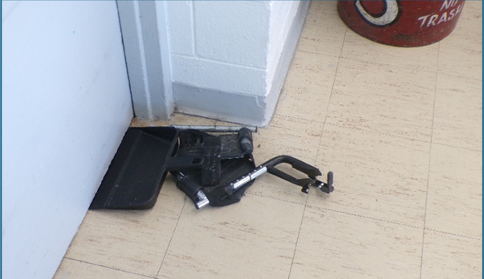
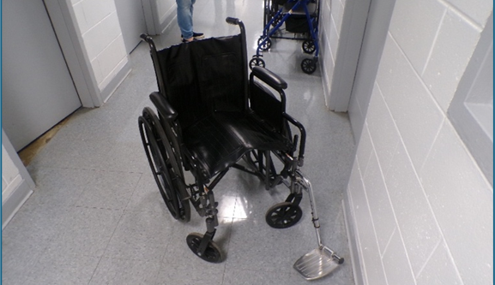
"The wheelchair vendor went out of business and no longer does repairs. The cost of repairs now outweighs the cost of a new chair."

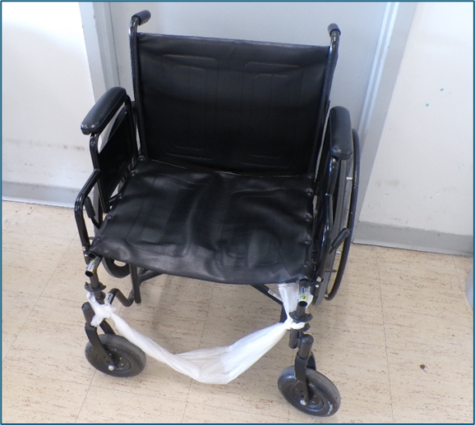
Office of Legal Affairs, June 2025

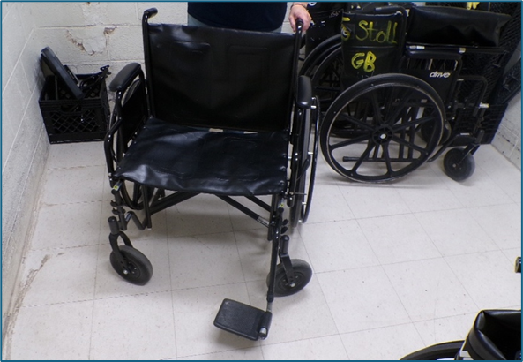

Wheelchair System Failures
Chronic Shortage of Wheelchairs
WHV lacks adequate equipment to meet the basic mobility needs of its population. As of July 2025, MDOC reported that 126 individuals had active "for distance" wheelchair details. At the same time, the facility reported having only 56 "distance" wheelchairs allocated across its 14 housing units.
This created a deficit of 70 wheelchairs, meaning that on any given day dozens of individuals with a verified medical need for a wheelchair are simply unable to get one.

MDOC reported it has moved from a repair system to a replacement system, related to cost. However, the significant undersupply of wheelchairs indicates failures in the replacement system as well.

126 Needed - 56 Available = 70 Lacking

Wheelchair System Failures

Non-compliant Prescribing System
For individuals whose medical details specify they require an attendant to push them due to a condition that prevents self-propulsion, such as inadequate upper body strength or a chronic medical condition like congestive heart failure, the access barriers are more severe.

In a Detroit Free Press article (2/26/19) covering Michigan Department of Corrections violations of the ADA, journalist Paul Egan reported that Jeri Taeckens, a blind individual formerly incarcerated at WHV, described a systemic lack of reliable prisoner aides. She stated this problem affected not only her but also prisoners who used wheelchairs, causing them to miss meals and appointments, and added that the wheelchairs themselves were often in poor repair. Egan wrote, "At the women's prison, a lack of reliable access to aides results in such prisoners missing meals and appointments, and the wheelchairs themselves were often in poor repair and/or beneath ergonomic standards, she said."

WHV has continuously failed to assign and manage a sufficient number of wheelchair attendants. There is no accountability system; attendants are not consistently assigned to specific users, resulting in an unreliable daily process where individuals with disabilities must repeatedly request assistance to access meals, medical care, and other critical services. The procedures for obtaining assistance are not standardized and place the entire burden on the wheelchair user.

Wheelchair System Failures
- Inconsistent and Unreliable Procedures: Procedures for obtaining wheelchair assistance varied by housing unit and were often ineffective. In some units, wheelchair users were expected to secure an attendant in advance, a practice that fails for same-day needs such as meals or medication. Mandatory 6:00 AM lobby meetings frequently fail because attendants do not show up. Officers often resort to last-minute, unreliable solutions like calling attendants from other units. When this fails, wheelchair users are forced to find their own solutions, routinely having to request to "catch a ride": asking others traveling in the same direction to push them where they need to go. These "rides" are rarely free, and the individual risks being stranded at some point along their journey. As a result, wheelchair users were routinely left without assistance and unable to reach meals, medication lines, or required appointments.

- Restrictive and Arbitrary Policies: Attendants reported being subject to informal limits on the number of times they were required to assist each day, leaving wheelchair users stranded for additional needs such as meals or medical appointments.

- Failure to Conduct Proper Medical Assessments: MDOC sometimes reduced or canceled wheelchair attendant assistance without documented medical evaluations of an individual’s ability to self-propel, raising concerns about medical appropriateness and due process.

*Methodology, data sources, and detailed calculations supporting these findings are provided in Appendix C (Wheelchair System Data & Observations)

MDOC Contradictions & Dismissive Responses
DRM's attempts to resolve these issues have been met with inconsistent and dismissive responses from MDOC officials.

- Contradictions in Policy: When asked why WHV changed its policy on assigning and storing distance wheelchairs, OLA called DRM's understanding "incorrect" (7/16/25) and stated individuals with distance wheelchair details were never assigned a wheelchair or allowed to keep chairs in their cells. This contradicts both the lived experiences of many wheelchair users and DRM’s review of individual responsibility contracts, which showed that such wheelchairs were individually assigned.

- Admission of No Standards: MDOC stated "the distance they're traveling does not matter" for a distance wheelchair detail (8/22/25). However, according to statements from multiple individuals, unit officers regularly use their own discretion to deny wheelchair use based on distance, demonstrating a clear policy-to-practice failure. This admission is further contradicted by a WHV Wheelchair Report from April 2025, which includes medical orders that themselves specify distance limitations and allowances.

- Dismissal of Concerns: When DRM escalated these issues to OLA and the OAG, OLA responded the complaints received from wheelchair users were not legitimate and blamed a "disconnect in understanding." They dismissed widespread, firsthand accounts of hardship by suggesting the "determination of 'medical need' may differ from the desires of the prisoner," treating the accounts of incarcerated individuals and their advocates as unreliable regarding their own disabilities.

The following quotations, drawn from complaints received by DRM over multiple years, reflect the hardships wheelchair users experience within WHV.
"My wheelchair is broken. It has no footrests and I'm sitting on bars. Custody told me if I use a plastic bag to hold my feet again, they will ticket me. And it's best not to put a pillow on the seat. That's also a ticket.
Health Services and WHV set us up to fail all the way around." (Wheelchair User, December 2025)
"I had to find a volunteer because I had no aide, as there wasn’t enough aides in the unit.” (Wheelchair User, 11/30/2020)

“I was moved to [housing unit]. Since then, I’m experiencing wheelchair aide problems again, not having any. When I approached [staff] about this I was told they didn’t have any permanent aides and didn’t know any names of any.” (Wheelchair User, 5/30/2020)

“[Staff] told inmates there will not be any more [additional] wheelchairs in units and if they want to go to chow they will walk. We have diabetics that at times go too low… those who have seizures. If someone feels they are not able to walk that far they go without eating.” (Wheelchair User, 10/9/2025)

"I miss numerous meals due to no aide or no wheelchair to use.
Custody blames Health Services and Health Services blames custody. Health Services will not authorize meals in the unit so I can eat, and the dietician now refuses to order diabetic snacks for me. She told me I don't go to chow often enough to have them."

Wheelchair User, December 2025

"Being diabetic and taking insulin, I must eat, but I cannot walk to the chow hall. I lose my balance easily due to neuropathy in my feet, legs, and hands. There are days when my legs hurt so bad that I cannot walk to diabetic lines." (Wheelchair User, December 2025)

“I have a wheelchair accommodation due to health concerns that make it difficult in walking especially long distances… and difficulty in getting to many of my appointments due to a lack of adequate wheelchair aides. There are many times I miss appointments to health care, Outpatient Mental Health, the law library, and legal writer appointments. All of these are important appointments having to do with my physical and mental health as well as my access to the courts. I live in a housing unit that has many individuals in wheelchairs and there are not enough wheelchair aides to push everyone everywhere they have to go.” (Wheelchair User, 10/21/2025)

"I cannot tell you how many times WHV has made (redacted) push herself backwards using her toes to get to diabetic lines and back. She gets stuck on an incline many times. Officers will not get an aide to push her, nor will they wake any up to push her. For years now, if she wants insulin she uses her toes and pushes herself." (Wheelchair User, November 2025)

“I am writing because there is a shortage of wheelchair aides here at the facility, and myself and others who have wheelchair details due to serious medical conditions/disabilities are having to forego callouts and major programming as a result of this shortage. I have written the warden, RUM [Resident Unit Manager], PCs [Prisoner Counselor], and anyone else who will listen. I have also written to our field tech only to have her say this is a classification issue.” (Wheelchair User, 12/5/2023)

“I have been having problems getting aides to push me and with staff having the aides do their job.” (Wheelchair User, 9/18/2025)

“We have no one to handle wheelchairs or wheelchair repairs. If they say they do, they are lying to your face. Even officers here want to know why we have no wheelchairs.” (Wheelchair User, 10/23/2025)

“I’m [redacted] old with end stage [redacted] and I am wheelchair bound. However, for months I have not had a working wheelchair. The wheelchair person refuses to give me a workable wheelchair. My original wheelchair had a defective seat. It tore apart and the chair became useless to me – I had no seat to sit in. Instead of going through channels, she left me with a very used chair that I could only go backward in. I am in the [redact]… I found another chair (with help from other inmates here) in a pile of broken, unrepaired wheelchairs. It has only one wheel that’s right, so I don’t know how long this will work …I can’t crawl, so when this breaks for good I will be left somewhere without a wheelchair.” (Wheelchair User,1/30/25)
“[Redacted] got a new wheelchair in July and soon after the rubber came off the tire. [Redacted] told healthcare about it who confiscated the chair and got her an old rusty used one. [Redacted] states she has contacted [WHV staff] several times over the last few months with no response.”

Wheelchair User, 2/3/25

RECOMMENDATIONS
To remedy these violations and prevent further harm, DRM recommends MDOC immediately implement the following operational and systemic changes:

- Assign individual wheelchairs to all users, ending the flawed communal pool system.

- Immediately notify all wheelchair users that if they need a wheelchair attendant, they must have a detail for a wheelchair attendant and provide instructions on how to request an assessment for an attendant.

- Assign specific attendants to specific users to ensure accountability and reliability, with a backup attendant pool on call in case of assigned attendant unavailability.

- Create and implement clear, standardized procedures for requesting and receiving attendant assistance.
- Post clear, accessible instructions for requesting and receiving attendant assistance in all housing units.
- Develop and implement written procedures for the wheelchair attendant position.
- Provide enough wheelchairs to serve all users and maintain a pool of reserve wheelchairs for use in case a wheelchair breaks or the number of wheelchairs needed increases.
- Conduct an emergency audit to immediately repair or replace all broken wheelchairs.

- Implement regular, documented protocols for wheelchair inspection and maintenance.

- Expand training for all custody and healthcare staff on ADA obligations.

Conclusion

The evidence in this report documents the Michigan Department of Corrections has maintained conditions at Women's Huron Valley Correctional Facility that routinely endanger wheelchair users, failing to meet Americans with Disabilities Act obligations and basic standards of care.

The "distance wheelchair" system is structurally flawed and insufficient by ADA standards. It denies individualized accommodations and requires disabled individuals to compete for access to poorly maintained equipment and unreliable assistance.

MDOC officials have been made aware of these failures for years. Their consistent response has been to dismiss the concerns of those affected and the documentation provided by advocates. The result is a facility where access to food, medicine, and mobility depends on chance and the discretion of staff rather than guaranteed rights.

These conditions require immediate correction. MDOC must take prompt action to address these issues and meet ADA requirements. The recommendations in this report provide a clear path for compliance. Implementation represents both a legal requirement and a necessary systemic correction.
The ADA mandates that necessary medical equipment must be provided to the individual to guarantee reliable, equal access to programs, services, and activities.

This requirement extends to individuals who are incarcerated in prisons and detention facilities.

DRM, 2026

Appendix A: Meal Attendance Data & Methods

The most consistent complaints DRM received from wheelchair users at WHV concerned missing meals, medications, and programming due to unavailable wheelchairs or attendants. To quantify this issue, DRM requested and analyzed meal attendance and medication line records for wheelchair users. The following data documents the extent of access limitations within the facility.

Data Sources Reviewed
DRM analyzed MDOC data related to meal attendance for 82 individuals with wheelchair attendants. The data reveal significant access problems.

Time Period Covered
MDOC provided breakfast, lunch, and dinner attendance records for 141 days (January 1, 2025
- May 22, 2025).

Assumptions Used in the Analysis
DRM assumed each individual should have attended breakfast, lunch, and dinner one time every day. To avoid skewing results with individuals whose incarcerations may have begun after January 1, 2025, or ended before May 22, 2025, total days were calculated using the first day MDOC recorded the individual attended a meal line to the last day MDOC recorded the individual attended a meal line. If an individual attended every meal line for the full span of the reported days, they should have received 423 meals.

Method for Calculating Missed Meals
On average, women needing wheelchair attendants only received 51.23% of the meals they should have.
Treatment of in-cell meals: In the data, some of the women received a high number of in-cell meals, meaning MDOC staff brought the meal to them instead of having them eat at the chow hall. When DRM excluded women receiving a high number of in-cell meals from the data, the women served primarily at Food Service received 42.07% of the meals they should have.

Summary of Aggregate Results
62 of the 82 women missed more than a third of their meals, or more than one meal every day. This is equivalent to skipping breakfast, lunch, or dinner every day for more than five months. 46 of the 82 women missed more than half of their meals. 10 out of 82 women missed more than 75% of their meals. Over the course of approximately 141 days, the 82 women combined to miss 17,621 total meals, for an average of 1.52 meals missed per woman, per day.

Women have often reported not being able to get to medication lines due to a lack of wheelchair attendants. To investigate this, DRM reviewed MDOC Electronic Medication Administration Records (EMARs) for 85 women with details for wheelchair attendants, to estimate how often the women were able to get to pill lines for needed medications.
Data Sources Reviewed
The EMARs MDOC provided span 193 days (February 1, 2025 - August 12, 2025) and are separated by individual. Each individual’s EMAR contains columns for the pill line date, which pill line (AM, Noon, PM), the prescription number, the name of the medication, and a frequency code. The frequency codes indicate how often the person is supposed to take the medication. For example, the code “QHS” means the person should take the medication once a day, at bedtime.

Medication Categorization Method
DRM reviewed all 85 EMARs to identify and categorize the prescribed medications based on what they treat, using medication descriptions from Mayoclinic.org to decide the most common treatment use.

Rationale for Medication Categories
DRM focused on three medication categories: Seizure, High Blood Pressure, and Diabetes. DRM chose to focus on these medications for three main reasons. First, they often treat serious medical conditions. Second, they are for conditions that tend to be long term, reducing the possibility that someone would suddenly stop taking them. Third, unlike psychotropic medications, they are not used to treat conditions that may cause the individual to decide to skip taking them voluntarily. It is entirely possible MDOC prescribed some of the categorized medications to treat other things. The full list of medications in each category is below.
Seizure Medication

Carbamazepine Divalproex Sodium Gabapentin Lamotrigine Levetiracetam Oxcarbazepine Phenytoin Pregabalin Topiramate
High Blood Pressure Medication
Amlodipine Carvedilol Chlorthalidone Clonidine Furosemide Hydrochlorothiazide Lisinopril
Losartan Metoprolol Tartrate Prazosin Sacubitril/valsartan Spironolactone Verapamil

Blood Sugar Medications

Dapagliflozin Glipizide Insulin NPH
Insulin Glargine (Lantus) Insulin Regular Metformin
Lantus Subcutaneous

Assumptions Used in the Analysis
- DRM counted medications with no pill line listed towards the total they received, to account for MDOC providing the medication outside of pill lines.

- DRM did not count medications individuals took with no pill line listed in the total they should have taken, to avoid counting one-off medications.

Summary of Aggregate Results
Out of the 85 EMARs DRM reviewed, forty-four individuals (51.8%) were on at least one seizure, high blood pressure, or blood sugar medication. Thirty-eight individuals (44.7%) received seizure medications, ten individuals (11.8%) received high blood pressure medications, and twelve people (14.1%) received blood sugar medications. Twelve individuals (14.1%) received medications in two or more of DRM’s categories, with 2 individuals (2.4%) receiving medications in all three categories.

In total, there was no category in which the group as a whole received even 25% of their medications. High blood pressure medications fared the best, at 24.6% (1065 out of 4332), with blood sugar medications at 19.3% (1478 out of 7649) and seizure medications at 18.9% (3412 out of 18054). For seizure medications, the individual who received the highest percentage got 82.1% of her medications. For high blood pressure, 83.9%. For blood sugar medications, like insulin, the woman receiving the highest percentage got only 56.2% of her medications.

Out of the 44 women receiving medications in the three categories, 14 (31.2%) received less than 10% of their medications. As stated below, even if DRM’s estimates are off by a significant amount in MDOC’s favor, women with details for wheelchair attendants are not able to get to pill lines to take their needed medications. This is not an issue of a few individuals deciding to skip medications. The outliers are those that get more than half of their medications: only 6 women (13.6%) did.

Data Limitations
For some individuals, the first pill line attendance listed is well after February 1, 2025. DRM does not have data on when the individuals were first prescribed their medications, so we cannot say whether they should have been attending medication lines. Given the long-term nature of medications considered, DRM counted days from February 1, 2025, to the day the person first attended a med line as days the individual should have received their medications. DRM did not account for individuals passing away, leaving prison, or voluntarily skipping medications in its review.

Given those data limitations, DRM’s numbers are an admittedly rough estimate of how many medications an individual should have received. However, the estimate paints such a stark picture of medication inaccessibility for women who require wheelchair attendants but there would need to be overwhelming evidence to the contrary to negate DRM’s conclusion: women with wheelchair attendant details were not able to get to pill lines and were not able to get the medications they needed.

During a large-scale monitoring visit in May 2025 and a follow-up visit in October 2025 to document wheelchair conditions, DRM staff spoke with multiple individuals with permanent wheelchair details and observed similar conditions.

Observed Wheelchair Conditions
Most of the distance wheelchairs had one or no footrests. MDOC reported that four distance wheelchairs were assigned to each housing unit. However, monitors found an inconsistent number of wheelchairs in the units at a time when all prisoners were required to be in their cells and no distance wheelchairs should have been outside of the unit. Furthermore, many housing units had more than four distance wheelchair users. DRM spoke with an individual housed in the infirmary who has a permanent wheelchair detail. She demonstrated that one of her wheelchair's wheels did not function properly and the brakes were inoperative.

Wheelchair Repair and Maintenance Information
DRM's inquiries into WHV's repair process revealed inconsistent and insufficient responses from the administration. Having received many reports concerning broken wheelchairs, DRM inquired with WHV Health Services in June 2024 about their repair process. Health Services administration stated the facility was addressing the issue, claiming, "We had a vendor come to the facility that had to lay eyes on all the chairs requiring repairs... The chairs are now in the process of being redistributed to the units."

However, after observing the continued poor conditions during our May 2025 visit, DRM followed up with the Office of Legal Affairs (OLA) in June 2025. OLA provided a different account, stating, "The wheelchair vendor went out of business and no longer does repairs. The cost of repairs now outweighs the cost of a new chair." OLA further explained that an individual with a broken wheelchair could simply request a new one, a solution that has proven ineffective given the documented equipment conditions.



Disability Rights Michigan
4095 Legacy Parkway
Lansing, MI 48911

Phone: 517.487.1755 800.288.5923
Fax: (517) 487-0827
www.drmich.org

Disability Rights Michigan is tax-exempt under Section 501(c)(3) of the Internal Revenue Code. Contributions are tax-deductible and
help us provide services to Michiganders with disabilities.

Portions of this report may be reproduced without permission of Disability Rights Michigan, provided the source is appropriately credited.

The U.S. Department of Health and Human Services Administration for Community Living and donors shared in the cost of funding this publication. The contents do not necessarily represent the official view of any funder.

Disability Rights Michigan is the Protection and Advocacy System for Michigan

