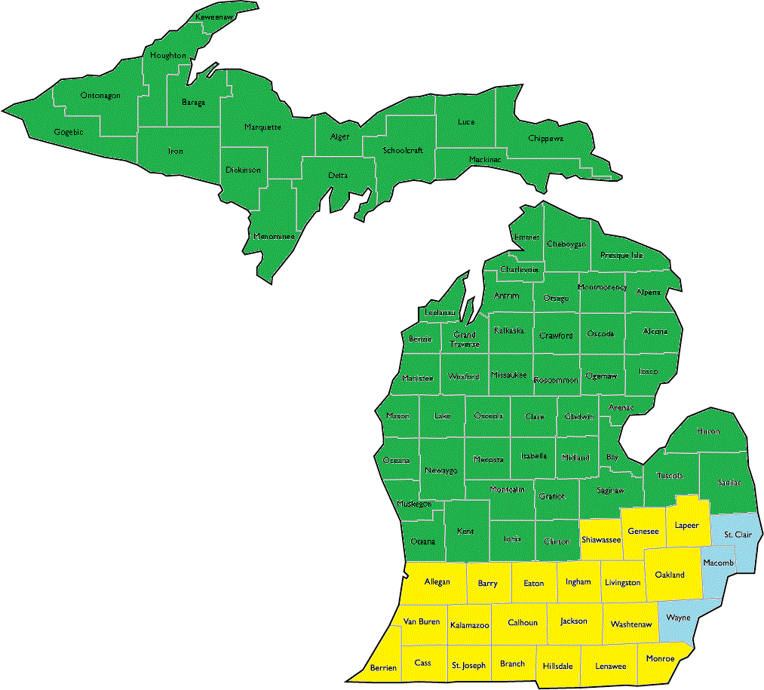
Michigan’s Work Incentives Planning and Assistance Projects

The Arc Michigan WIPA
1325 S Washington Ave
Lansing MI 48910
800-292-7851
Fax – 517-487-0303
Cathy McRae, Project Coordinator
cathy.mcrae@arcmi.org

Starr Benefits Planning
640 3 Mile Rd, Suite A
Grand Rapids, MI 49544
Office: 877-370-9675
Fax: 616-363-5334
Carrie Benchich, Project Coordinator
cbenchich@starrandassociates.net

MI-UCP WIPA
23077 Greenfield Rd, Ste. 205
Southfield, MI 48075
800-827-4843
Kendall Brocavich, Project Coordinator
kbrocavich@mi-ucp.org

More Resources
Ticket to Work Helpline: 866-968-7842 (V) 866-833-2967 (TTY)
Ticket to Work Online: choosework.ssa.gov
Disability Rights Michigan Protection & Advocacy for Beneficiaries of Social Security (PABSS): 800-288-5923
Disability Benefits 101: mi.db101.org
Social Security My Account: www.ssa.gov/myaccount/
MDHHS MIBridges: newmibridges.michigan.gov

Alcona | Dickinson | Lake | Oceana
Alger | Eaton | Lapeer | Ogemaw
Allegan | Emmet | Leelanau | Ontonagon
Alpena | Genesee | Lenawee | Osceola
Antrim | Gladwin | Livingston | Oscoda
Arenac | Gogebic | Luce | Otsego
Baraga | Grand Traverse | Mackinac | Ottawa
Barry | Gratiot | Macomb | Presque Isle
Bay | Hillsdale | Manistee | Roscommon
Benzie | Houghton | Marquette | Saginaw
Berrien | Huron | Mason | St. Clair
Branch | Ingham | Mecosta | St. Joseph
Calhoun | Ionia | Menominee | Sanilac
Cass | Iosco | Midland | Schoolcraft
Charlevoix | Iron | Missaukee | Shiawassee
Cheboygan | Isabella | Monroe | Tuscola
Chippewa | Jackson | Montcalm | Van Buren
Clare | Kalamazoo | Montmorency | Washtenaw
Clinton | Kalkaska | Muskegon | Wayne
Crawford | Kent | Newaygo | Wexford
Delta | Keweenaw | Oakland

