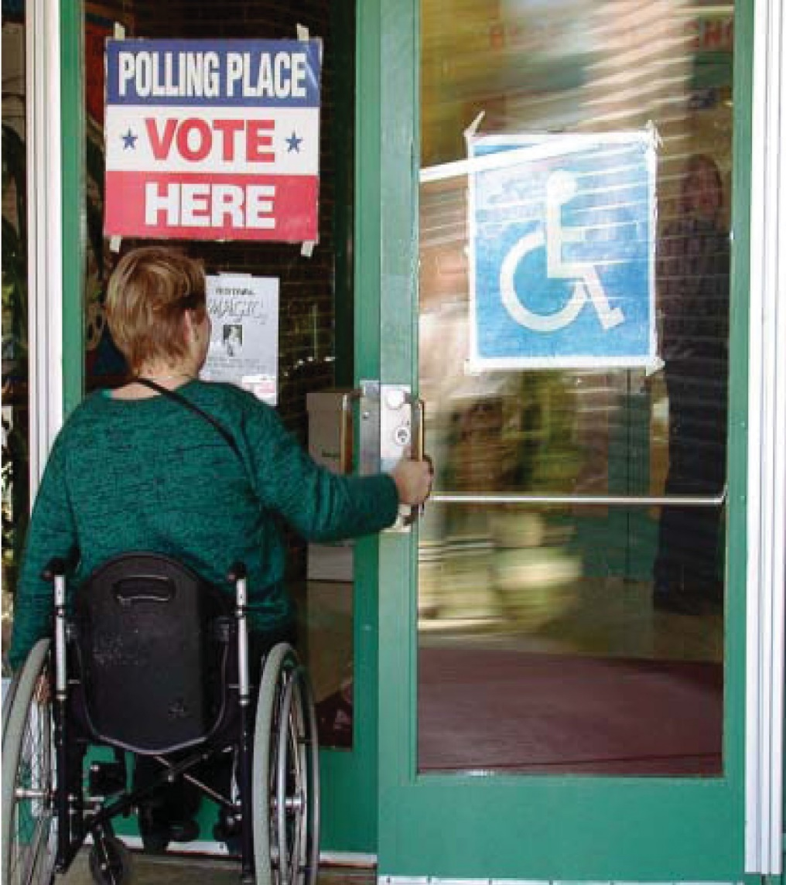

Michigan Protection & advocacy Service, inc.
“a call to action”, 2011

“Protecting the rights of Persons With Disabilities”

A Call to Action – Unfinished Business to Ensure Michigan Voters with Disabilities Have Access to the Polls in 2012

June 2011

A Call to Action – Unfinished Business to Ensure Michigan Voters with Disabilities Have Access to the Polls in 2012

A Public Report on Polling Place Accessibility in Michigan

Public Report by
Michigan Protection and Advocacy Service, Inc.

2011

Acknowledgements

Michigan Protection and Advocacy Service (MPAS) is Michigan’s designated agency to advocate
and protect the legal rights of persons with disabilities, mandated by federal and state law. MPAS receives funding from the Administration on Developmental Disabilities, the Center for Mental Health Services – Substance Abuse and Mental Health Services Administration, the Rehabilitation Services Administration, the Social Security Administration, the State of Michigan, and from private donations.

Funding for this report has been made possible through the U.S. Department of Health and Human Services, Administration for Children and Families, and the Administration on Developmental Disabilities. The contents are the sole responsibility of the author and do not necessarily represent the official views of the U.S. Department of Health and Human Services.

© 2011 by Michigan Protection and Advocacy Service, Inc. This publication may be reproduced in part or in its entirety for noncommericial purposes as long as appropriate credit is given.

Michigan Protection & advocacy Service, inc.
“a call to action”, 2011

Table of Contents
Executive Summary 5
Midterm Report 6
Michigan’s Polling Place Accessibility Project 7
Communicating Accessibility Problems with Election Officials 10
Next Steps 11
In Summary 11
Accessibility Rate Per County 13

Michigan Protection & advocacy Service, inc. “a call to action”, 2011

executive summary

In Michigan, voters with disabilities face obstacles at voting locations often because their polling place lacks physical accessibility. The Help America Vote Act (HAVA) acknowledged that voters with disabilities face unique obstacles at the polls and authorized funding for the federally mandated
Protection and Advocacy Voting Access programs (PAVA) to help remove these barriers. Unfortunately,
this vital mandate has been targeted for elimination in the President’s proposed 2012 budget.

HAVA charged Michigan Protection and Advocacy Service, (MPAS), and other Protection & Advocacy agencies around the nation with helping to ensure the full participation of individuals with disabilities in the electoral process, including registering to vote, casting a ballot, and accessing polling places.

The PAVA program at MPAS is designed to ensure that every eligible Michigan resident receives equal access to their polling location and has the opportunity to cast an independent secret ballot. MPAS Staff members are on the ground providing advice, technical assistance, and training to election officials about voting accessibility across the spectrum of disabilities. The agency also provides outreach and training to voters with disabilities, poll workers, and service providers. MPAS and the Secretary of State of Michigan have partnered over the past six years working toward this goal, which has been effective in increasing physical access to polling locations throughout Michigan.

Voting is a fundamental right protected by the United States Constitution, upheld by the Supreme Court and subject to intense public scrutiny each election cycle. Provisions within these protections prohibit discrimination against people with disabilities in the electoral process. Exercising their Constitutional right, however, has continued to be a challenge for individuals with disabilities despite changes made to federal and state laws intended to ensure full participation.

key summary

u Disability advocates have visited 95% (3,457) and reviewed the exterior of polling locations in Michigan.

u Upon initial review, Michigan Protection and Advocacy Service found that only 75% of 3,457 Michigan polling places were compliant under the Americans with Disabilities Act.

u After working with state and local officials, it is anticipated that Michigan’s accessibility
rate will be increased to 90% by 2012.

u Of the locations that were inaccessible, 60% had one barrier, 30% had two types of barriers, and 6% had three or more types of barriers.

u Only six of the 84 counties in Michigan were 100% physically accessible upon initial visit.

u MPAS continues to receive complaints regarding the AutoMARK, Michigan’s accessible
ballot marking device.

Michigan has made great strides toward accessibility at the polls. This report will highlight the steps taken to ensure that all polling locations throughout Michigan are accessible to voters with disabilities. In addition, the report will offer recommendations for Michigan to achieve and maintain an accessibility rate of 100%.

Michigan Protection & advocacy Service, inc.
5 “a call to action”, 2011

2010 Midterm Report

Acknowledging widespread irregularity throughout the country, Congress passed the Help America Vote Act (HAVA) in 2002. HAVA included sweeping legislation intended to modernize the electoral system for all voters, including those with disabilities. The Help America Vote Act reinforced the application of Title II of the Americans with Disabilities Act and Section 504 of the Rehabilitation Act. Furthermore, in 2004, Michigan lawmakers amended Michigan election law (Public Act 92 of 2004) to require the removal of physical barriers at polling locations. Irrespective of both federal and state law, 25% of Michigan’s voting locations continued to be inaccessible for the November 2010 general election. To achieve an all-encompassing voting standard for the fifty states, HAVA included two key components for the disability community:

u All polling places must have at least one voting system which allows all citizens to cast a ballot privately and independently, whether or not one has a disability.

u States must ensure accessibility at all public polling places in a manner compliant with the Americans with Disabilities Act (ADA).

Accessible Voting System
In 2004, the disability community and the Michigan Secretary of State’s Bureau of Elections (BOE) carefully began assessing which accessible device would best fit the needs of Michigan voters, and in 2006, selected the AutoMARK. The AutoMARK is an accessible ballot marking device that can be used by all voters with or without disabilities.

Although every polling location is equipped with the AutoMARK, each municipality is responsible for making sure it is set up and operating properly. Unfortunately, MPAS continues to receive complaints about the AutoMARK. Voter complaints have included the following: the AutoMARK was boxed up on Election Day, unplugged, jammed up, turned off, or set up so other voters could see the “secret” ballot. Complaints concerning jammed ballots have been greatly reduced since the last round of updates were completed. Because the AutoMARK is used only on Election Day, MPAS relies on voter feedback to correct these kinds of problems. MPAS continues to monitor and respond to complaints as they arise.

Accessible Polling Places
Under HAVA, the federal government allocated money to assist with the purchase of accessible equipment like the AutoMARK, but also to help municipalities make their polling places physically accessible. Congress recognized that in order for people to use the accessible voting machines, the building must also be accessible so voters can access the polling location and voting equipment. It is the local election officials’ responsibility to make sure all polling locations are accessible on Election Day. To help cover the expense for removing barriers at polling locations, the Michigan BOE administers a grant program called Access for All, under the U.S. Department of Health and
Human Services with funding allocated through HAVA, to help the state comply with HAVA. In most

Michigan Protection & advocacy Service, inc.
“a call to action”, 2011 6

circumstances, the Access for All grants cover all costs associated with accessibility upgrades for polling locations.

When Michigan’s State Plan to implement provisions under HAVA was initiated in 2004, municipal clerks were required to complete an accessibility checklist to determine whether or not their locations were accessible. This was one of the state’s first attempts to gather information on Michigan’s polling place accessibility. During this time, MPAS and other organizations were working closely with individual election officials on polling location reviews and were also training the municipal clerks on the accessibility requirements. MPAS also spent a considerable amount of time assisting clerks with assessing the accessibility of their polling locations and helping them apply for Access for All grant money. MPAS found that the accessibility data provided by clerks was not, in certain instances, wholly reliable.

MPAS brought this to the Bureau of Election’s (BOE) attention and shared independent accessibility reviews with them. The BOE has since increased efforts to ensure the accuracy of reporting by improving communication and requiring additional documentation from the clerks.

In 2008, MPAS started to assess municipal polling locations randomly, without notifying the election official in advance. After compiling this data on polling locations statewide, the systemic issue of inaccessibility became a heightened concern. Once these concerns were communicated to the Bureau of Elections, they backed a new initiative in 2010 dramatically increasing their involvement in the advancement of polling place accessibility.

This same year, the federal government began reviewing how the states were spending HAVA funds. This fueled speculation that the federal government would eliminate the monies available under HAVA, since some states had not spent their money rather placing it in an account and allowing the funds
to gain interest. Concerned that Congress would pull the allocated funds completely, which would prevent municipalities from accessing money to make polling places accessible, MPAS, along with the Michigan Bureau of Elections, embarked on a project designed to ensure 100% physical accessibility at all Michigan polling places.

Michigan’s Polling Place Accessibility Project

In 2010, Michigan started building the framework of a statewide plan to reach 100% polling place accessibility. MPAS and the Bureau of Elections strengthened their partnership in order to achieve this goal. Within the plan, MPAS would review the exterior of all locations throughout the state. Michigan has approximately 3,600 polling places in total. MPAS had already gathered information on 530 polling places prior to 2010, therefore, did not revisit those locations (some were initially accessible and others MPAS worked closely with clerks to improve accessibility. MPAS is still working with clerks to bring the remaining 57 of the 530 polling locations into compliance). MPAS was able to visit the remaining 2,927 polling locations in 2010.

Michigan Protection & advocacy Service, inc.
7 “a call to action”, 2011

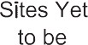
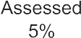
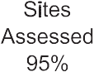
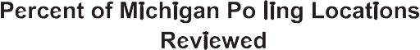

Overall, MPAS conducted on-site reviews of 95% of the polling places in Michigan.

The on-site reviews conducted in 2010, exposed nearly 25% of the polling places that remained physically inaccessible as required by the Americans with Disabilities Act Accessibility Guidelines (ADAAG).

Barriers

Of the 3,457 polling locations noted above, 2,927 were assessed between May-August 2010. Using the ADAAG as a benchmark to determine physical accessibility, over 800 polling locations within the 2,927 locations visited had physical barriers failing to comply with the ADAAG – barriers that create potential difficulties to voters with disabilities on Election Day.

Barriers can prevent people with disabilities from fully participating in all aspects of society because
of their disability. This might include architectural barriers, physical barriers, communication barriers, attitudinal barriers, cultural barriers, etc. Throughout this project, MPAS’ reviews focused primarily on physical and external barriers, which are defined as something material that blocks passage. Physical barriers addressed in this report include objects in the environment such as inaccessible doors or doorways, inaccessible elevators or lack thereof, inaccessible door hardware, inaccessible parking, etc.

Michigan Protection & advocacy Service, inc.
“a call to action”, 2011 8

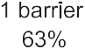
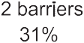
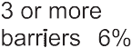
Among the 2,927 polling locations visited in 2010, 28% did not meet accessibility standards. Based on discussions with the BOE in 2008, when MPAS completed the unannounced visits, clerks were not only notified with a letter from MPAS concerning accessibility, but they were also notified by the Bureau
of Elections. MPAS and the BOE required prompt reply about the municipalities plans to meet ADA requirements. The letters contained a photograph of the problem area(s), along with the appropriate ADAAG citation. Within a five month period, letters were sent to over 440 municipalities concerning approximately 800 polling locations.

As shown below, 28% of the polling places visited in 2010 had some type of physical barrier present at the time of review.

The following chart highlights the most common number of physical barriers discovered at each location.

A majority of the locations reviewed had only one physical barrier present. While the largest and most frequent problem was related to parking, the types of barriers at each location varied as shown in the following chart.

Michigan Protection & advocacy Service, inc.
9 “a call to action”, 2011

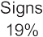
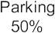
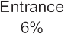
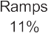
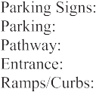
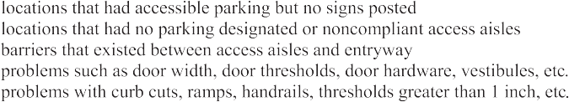

Communicating Accessibility Problems with Election Officials

After completing the on-site reviews, MPAS notified municipal clerks of locations where barriers were discovered. Within a four-month period, over 440 letters were sent to election officials. By the end
of 2010, 88% of those clerks responded back to MPAS with a plan of correction. In addition, MPAS provided technical assistance to the election officials on how to improve access to their polling location in order to come into compliance. Based on the responses received from clerks, 43% informed us they would make the changes required; 31% corrected the barriers at the polling location; 9% were going
to apply for the Access for All grant; and the remaining responses varied from clerk using temporary equipment.

When a clerk informed MPAS that the work was completed, MPAS required documentation from each clerk proving or stating that the work had been completed, including photographs and/or copies of purchase orders. A majority of the clerks responded either with a plan of correction for spring 2011 or with a statement that the work was completed. MPAS is still waiting for some clerks to confirm that the work was done sufficiently. Once the removal of barriers at these locations has been verified, MPAS expects Michigan’s polling place accessibility rate to rise to nearly 90% – one of the highest in the nation. There remains, however, substantial work to be completed in the city of Detroit in order to reach this goal. The remaining 12% of clerks who did not respond to MPAS or the Bureau of Elections with a plan of correction will become a 2011 priority in order to attain 100% accessibility.

Michigan Protection & advocacy Service, inc.
“a call to action”, 2011 10

Next Steps

While the focus of this report has been on reaching the 90% accessibility rate, there would still be approximately 10% of polling locations in Michigan that are not accessible to all voters. Some clerks disagree with the findings and MPAS is working with those clerks.

In 2011, MPAS will be revisiting a number of polling locations that are still recorded as being inaccessible, breaking them into three categories: failure to communicate, work promised but documentation still needed, and locations requiring review by MPAS.

MPAS will focus attention on election officials who have failed to respond to MPAS’ communication attempts. This may involve revisiting the location (some clerks correct the problem even when they fail to respond), attending city council/township meetings, filing official HAVA complaints, and/or pursuing legal action under different funding sources. MPAS’ goal has always been to educate clerks and assist them with improving access first by proposing solutions to removing barriers.

In 2011, MPAS will also direct its attention to monitoring the correction plans that election officials have submitted to ensure that barriers are removed. MPAS will review the remaining 150 polling locations that have not been visited yet.

In Summary

Throughout the 2010 project, the partnership between MPAS and the Michigan Bureau of Elections (BOE) was crucial. The state reinforced the necessity of accessible elections. They followed up with each municipality whose polling place was noted as being inaccessible in order to determine the jurisdiction’s planned course of action. In addition, the BOE coordinated and extended Michigan’s polling place improvement grant well into the fall to assist municipalities in removing barriers to voting at no cost.

Local election officials can either upgrade their polling places (with or without grant funds) or relocate the polling place to an accessible site. The Bureau of Elections reports that due to the 2010 project, they have seen a large increase in the number of municipalities applying for grant money. In an effort to assist with the project, the BOE extended the typical grant cycle, giving clerks additional opportunity
to respond to MPAS’ letter and correct the problem(s) by using grant funds. The Michigan Bureau of Elections received 74 grant applications, the largest amount ever received in one grant cycle. Of those 74 grant applications, 66 applicants received letters from MPAS seeking a plan of correction - 89% of those who applied. A large number of municipalities have pledged to apply when the next grant period opens in early 2011.

If the HAVA/PAVA program survives the President’s proposed budget cuts, MPAS looks forward to continuing the partnership with the Secretary of State, ensuring all elections are accessible to all voters. Additionally, MPAS encourages clerks to reach out to local disability groups for future trainings. Listed below are additional recommendations moving forward.

summary Recommendations:

Michigan Protection & advocacy Service, inc.
11 “a call to action”, 2011

u Local clerks must be required to notify the Bureau of Elections prior to relocating
polling places.

u Accessibility checks should be completed when clerks change polling locations to verify
accessibility. Reports (with photographs) should be submitted to the Bureau of Elections.

u New polling locations must be required to adhere to the Americans with Disabilities Act
Accessibility Guidelines.

u The advisory committee in charge of amending the State Plan (under HAVA) should re- convene and identify ways to hold clerks accountable and implement model oversight programs.

u Access for All grant money should be available throughout the year so accessibility problems can be addressed anytime they arise.

u The Bureau of Elections and local clerks should continue working with disability advocacy
organizations to complete year-round polling place accessibility audits and training to clerks.

Michigan Protection & advocacy Service, inc.
“a call to action”, 2011 12

Accessibility rate by County

CoUnTy | Polling | VisiTED | ACCEssiBlE | BArriErs | PErCEnT | % ACCEssiBlE | now | % now
 | loCATions |  |  | DisCoVErED | VisiTED | of THosE VisiTED | CoMPlETE | ACCEssiBlE

AlCONA | 12 | 12 | 8 | 4 | 100% | 67% | 3 | 92%
AlgER | 10 | 10 | 5 | 5 | 100% | 50% | 5 | 100%
AllEgAN | 37 | 37 | 35 | 2 | 100% | 95% | 1 | 97%
AlPENA | 15 | 15 | 8 | 7 | 100% | 53% | 1 | 60%
ANtRIM | 15 | 15 | 9 | 6 | 100% | 60% | 2 | 73%
ARENAC | 14 | 14 | 10 | 4 | 100% | 71% | 3 | 93%
BARAgA | 8 | 6 | 1 | 5 | 75% | 17% | 1 | 33%
BARRy | 23 | 23 | 18 | 5 | 100% | 78% | 1 | 83%
BAy | 49 | 48 | 36 | 12 | 98% | 75% | 1 | 77%
BENzIE | 13 | 13 | 6 | 7 | 100% | 46% | 4 | 77%
BERRIEN | 57 | 57 | 43 | 14 | 100% | 75% | 8 | 89%
BRANCh | 18 | 17 | 9 | 8 | 94% | 53% | 6 | 88%
CAlhOuN | 46 | 43 | 34 | 9 | 93% | 79% | 3 | 86%
CASS | 19 | 19 | 12 | 7 | 100% | 63% | 6 | 95%
ChARlEvOIx | 18 | 16 | 10 | 6 | 89% | 63% | 1 | 69%
ChEBOygAN | 20 | 20 | 14 | 6 | 100% | 70% | 5 | 95%
ChIPPEwA | 19 | 18 | 13 | 5 | 95% | 72% | 4 | 94%
ClARE | 19 | 16 | 13 | 3 | 84% | 81% | 2 | 94%
ClINtON | 28 | 26 | 24 | 2 | 93% | 92% | 1 | 96%
CRAwfORd | 7 | 7 | 6 | 1 | 100% | 86% | 0 | 86%
dEltA | 21 | 20 | 11 | 9 | 95% | 55% | 1 | 60%
dICkINSON | 15 | 15 | 6 | 9 | 100% | 40% | 5 | 73%
EAtON | 36 | 36 | 28 | 8 | 100% | 78% | 2 | 83%
EMMEt | 19 | 19 | 12 | 7 | 100% | 63% | 5 | 89%
gENESEE | 119 | 109 | 84 | 25 | 92% | 77% | 2 | 79%
glAdwIN | 17 | 17 | 11 | 6 | 100% | 65% | 1 | 71%
gOgEBIC | 10 | 10 | 7 | 3 | 100% | 70% | 2 | 90%
gRANd tRAvERSE | 28 | 27 | 27 | 0 | 96% | 100% | 0 | 100%
gRAtIOt | 23 | 23 | 16 | 7 | 100% | 70% | 2 | 78%
hIllSdAlE | 21 | 21 | 12 | 9 | 100% | 57% | 3 | 71%
hOughtON | 31 | 22 | 9 | 13 | 71% | 41% | 5 | 64%
huRON | 30 | 29 | 18 | 11 | 97% | 62% | 5 | 79%
INghAM | 95 | 81 | 78 | 3 | 85% | 96% | 0 | 96%
IONIA | 22 | 22 | 17 | 5 | 100% | 77% | 1 | 82%
IOSCO | 15 | 15 | 14 | 1 | 100% | 93% | 1 | 100%
IRON | 12 | 12 | 6 | 6 | 100% | 50% | 2 | 67%
ISABEllA | 25 | 25 | 19 | 6 | 100% | 76% | 1 | 80%
JACkSON | 47 | 45 | 34 | 11 | 96% | 76% | 2 | 80%
kAlAMAzOO | 97 | 97 | 79 | 18 | 100% | 81% | 7 | 89%
kAlkASkA | 12 | 12 | 8 | 4 | 100% | 67% | 1 | 75%
kENt | 209 | 207 | 174 | 33 | 99% | 84% | 11 | 89%
kEwEENAw | 5 | 4 | 4 | 0 | 80% | 100% | 0 | 100%
lAkE | 15 | 15 | 8 | 7 | 100% | 53% | 2 | 67%
Michigan Protection & advocacy Service, inc.
13 “a call to action”, 2011

Accessibility rate by County

CoUnTy | Polling | VisiTED | ACCEssiBlE | BArriErs | PErCEnT | % ACCEssiBlE | now | % now
 | loCATions |  |  | DisCoVErED | VisiTED | of THosE VisiTED | CoMPlETE | ACCEssiBlE

lAPEER | 24 | 24 | 20 | 4 | 100% | 83% | 2 | 92%
lEElANAu | 13 | 13 | 8 | 5 | 100% | 62% | 1 | 69%
lENAwEE | 30 | 30 | 23 | 7 | 100% | 77% | 4 | 90%
lIvINgStON | 48 | 45 | 35 | 10 | 94% | 78% | 0 | 78%
luCE | 4 | 4 | 3 | 1 | 100% | 75% | 0 | 75%
MACkINAC | 13 | 10 | 5 | 5 | 77% | 50% | 1 | 60%
MACOMB | 235 | 233 | 188 | 45 | 99% | 81% | 17 | 88%
MANIStEE | 15 | 15 | 11 | 4 | 100% | 73% | 3 | 93%
MARquEttE | 29 | 29 | 16 | 13 | 100% | 55% | 1 | 59%
MASON | 23 | 23 | 15 | 8 | 100% | 65% | 3 | 78%
MECOStA | 22 | 22 | 18 | 4 | 100% | 82% | 1 | 86%
MENOMINEE | 16 | 14 | 8 | 6 | 88% | 57% | 0 | 57%
MIdlANd | 38 | 29 | 22 | 7 | 76% | 76% | 4 | 90%
MISSAukEE | 17 | 17 | 14 | 3 | 100% | 82% | 3 | 100%
MONROE | 42 | 36 | 27 | 9 | 86% | 75% | 5 | 89%
MONtCAlM | 26 | 25 | 21 | 4 | 96% | 84% | 2 | 92%
MONtMORENCy | 9 | 9 | 7 | 2 | 100% | 78% | 1 | 89%
MuSkEgON | 72 | 71 | 68 | 3 | 99% | 96% | 2 | 99%
NEwAygO | 28 | 28 | 22 | 6 | 100% | 79% | 3 | 89%
OAklANd | 410 | 380 | 292 | 88 | 93% | 77% | 46 | 89%
OCEANA | 18 | 18 | 12 | 6 | 100% | 67% | 0 | 67%
OgEMAw | 16 | 16 | 10 | 6 | 100% | 63% | 5 | 94%
ONtONAgON | 14 | 10 | 3 | 7 | 71% | 30% | 0 | 30%
OSCEOlA | 18 | 18 | 14 | 4 | 100% | 78% | 2 | 89%
OSCOdA | 6 | 6 | 4 | 2 | 100% | 67% | 1 | 83%
OtSEgO | 10 | 10 | 7 | 3 | 100% | 70% | 2 | 90%
OttAwA | 88 | 88 | 79 | 9 | 100% | 90% | 5 | 95%
PRESquE ISlE | 16 | 16 | 10 | 6 | 100% | 63% | 3 | 81%
ROSCOMMON | 11 | 11 | 11 | 0 | 100% | 100% | 0 | 100%
SAgINAw | 75 | 75 | 61 | 14 | 100% | 81% | 8 | 92%
SANIlAC | 30 | 30 | 26 | 4 | 100% | 87% | 3 | 97%
SChOOlCRAft | 10 | 10 | 6 | 4 | 100% | 60% | 2 | 80%
ShIAwASSEE | 27 | 27 | 17 | 10 | 100% | 63% | 3 | 74%
St. ClAIR | 52 | 48 | 44 | 4 | 92% | 92% | 3 | 98%
St. JOSEPh | 17 | 17 | 12 | 5 | 100% | 71% | 2 | 82%
tuSCOlA | 25 | 24 | 16 | 8 | 96% | 67% | 2 | 75%
vAN BuREN | 23 | 22 | 19 | 3 | 96% | 86% | 1 | 91%
wAShtENAw | 106 | 100 | 70 | 30 | 94% | 70% | 0 | 70%
wAyNE | 568 | 519 | 325 | 194 | 91% | 63% | 28 | 68%
wExfORd | 20 | 20 | 14 | 6 | 100% | 70% | 1 | 75%
ToTAl | 3635 | 3457 | 2579 | 878 | 95.10% | 74.60% | 289 | 83%

Michigan Protection & advocacy Service, inc.
“a call to action”, 2011 14

“Protecting the rights of Persons With Disabilities”

4095 legacy Parkway, Suite 500
lansing, Michigan 48911-4263

517.487.1755 • 800.288.5923
(voice or tty) fax 517.487.0827
www.mpas.org

