Spring 2019
Exchange Newsletter

COVER
LaKeisha Receives a Speech-Generating Device
Assistive Technology Improves Quality of Life
In 2017, LaKeisha Cammon of Grand Blanc contacted Michigan Protection & Advocacy Service, Inc. (MPAS) regarding her rights to in-home supports. LaKeisha is living with muscular dystrophy, a disability she has had since birth, and has been residing in Medilodge of Grand Blanc for the past 5 years after being admitted for rehab. At 42 years old, LaKeisha is fighting for her right to leave the nursing home and live in the community.

Allison, an advocate on the Community and Institutional Rights (CAIR) team received LaKeisha’s case in June 2017. Allison informed LaKeisha that as a Medicaid recipient she has the right to receive certain assistive technology (AT). Allison pressured Medilodge staff for 18 months to file the appropriate Medicaid prior authorization paperwork that would allow LaKeisha to receive a speech-generating device (SGD) and a special motorized wheelchair. In December of 2018, LaKeisha received her SGD and has been able to effectively communicate with her new device.

"LaKeisha lived successfully in the community, with substantial in-home supports, for 7 years prior to Medilodge,” said Allison. “We often see clients lose their independence during rehab because they are denied their rights. Nursing homes are not required to file petitions on behalf of their clients and often see these requests as additional paperwork and beyond their standard of care.”

MPAS is appealing a Medicaid decision by MDHHS’ denying Lakeisha a motorized wheelchair which is critical to her mobility and medically necessary. With the appropriate ATs and in-home supports, LaKeisha can once again live successfully in the community. MPAS is committed to increasing her quality of life and her right to independence.

"MPAS is the first agency I think of when I need help,” said LaKeisha. “I am thankful for this device. I am able to communicate easier, text, engage on social media, and read. I have waited for over 18 months to receive this device and it will allow me to have a successful transition back into the community. MPAS has always been so helpful and I appreciate the work they have done on my behalf.”

If you or someone you know has questions related to assistive technology, please contact MPAS at 1.800.288.5923. All calls are free and confidential.
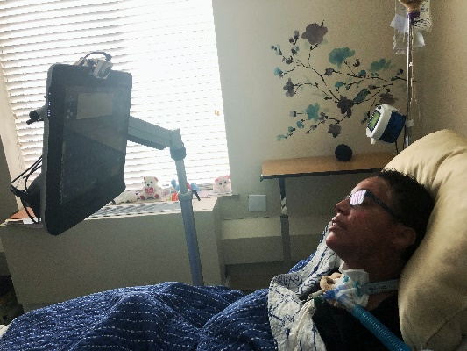
LaKeisha’s Speech-Generating Device

Page 2
Special Education Enforcement Case Settled; Another Filed
MPAS settled its litigation with a Michigan school district that had challenged a state complaint investigation by filing due process hearings against the child whose parents had filed the complaint. The settlement ended the district’s challenge and awarded compensation for the child’s education and attorney’s fees. MPAS filed its own due process hearing request in a second case involving a district that has failed to implement corrective action ordered by the state in another complaint finding.

Cci Restraint/Seclusion Rules Ripe for Reform
State licensing rules regulate the use of dangerous restraint and seclusion practices in child caring institutions (CCIs). The state House is now considering a bill, HB 4409 (Calley) to further regulate these practices in children’s therapeutic group homes, and the state Department of Health and Human Services (MDHHS) has indicated they might review the current licensing rules. MPAS now receives collective data on serious incidents of restraint and seclusion from all CMH-funded CCIs.

Legislature Considering “Raise The Age” Bills
Michigan is one of four states that automatically tries 17-year-olds as adults in the criminal justice system. Two sets of state legislation – one in the House and one in the Senate – are under consideration to raise the age of automatic adult prosecution to 18, in line with most other states. MPAS supports both packages.

Mpas Staff Named to Statewide Advisory Commissions
MPAS’ Executive Director was recently named to the Attorney General’s Elder Abuse Task Force. The Task Force will be looking at a host of abuse and neglect issues including aspects of guardianship and promotion of alternatives. MPAS staff also serve on two Secretary of State advisory panels on electoral systems and a Michigan Department of Education work group on improving outcomes for students receiving special education services.

Crisis Suit Survives Motion to Dismiss
MPAS filed suit last year to improve the provision of crisis intervention services for children. Most of the allegations in the suit survived a motion to dismiss filed by the state and are now moving forward.

Page 3
Congress Introduces Legislation to Support Competitive Integrated Employment
Federal legislators introduced three bills in Congress aimed at supporting competitive integrated employment. The Transformation to Competitive Employment Act, S. 260 (Casey) and H.R. 873 (Scott) would provide supports for states and service providers to move to competitive integrated employment and eliminate use of the subminimum wage. The Disability Employment Incentive Act, S. 255 (Casey) would provide hiring incentives to employers.

Governor’s Budget Includes Supports for People With Disabilities
The Governor’s proposed budget includes $120 million in increased state share for special education services. It also includes continued state funding for Early On and supports a small wage increase for direct support professionals. Finally, it includes additional funding to reduce waiting times for arrestees awaiting pretrial competency evaluations. MPAS signaled support for these initiatives, supported continued policy education to further increase direct support professional wages, and also participated in legislative briefings to expand the MI-Choice home nursing program.

Did You Know…
- MPAS monitors all public psychiatric hospitals, including the Center for Forensic Psychiatry, on a regular basis to prevent and redress abuse and neglect
- MPAS is now also monitoring the Huron Valley Center to investigate concerns about mental health services for female inmates in the correctional system
- Due in part to MPAS monitoring, the Caro Center will discontinue use of the “Overt Aggression Scale,” a form that was being used to justify resident restrictions and limitations in violation of the state Mental Health Code

MPAS Special Education Manual Under Renovation
The Wolters Foundation and former MPAS board member Kate Pew Wolters awarded MPAS a $50,000 grant to reconfigure its popular Special Education Advocate’s Manual for mobile devices. Staff began survey and focus group work to identify what the community wants in the new configuration. The manual and its related content on the Michigan Legal Help website have drawn nearly 15,000 views this year. The MPAS Board and staff extend their heartfelt thanks and gratitude to Kate and the Foundation for supporting their work.

Mpas Receives Largest Private Contribution In Its History
In March, former MPAS board member Terri Land and her husband, Dan Hibma, contributed $30,000 to support MPAS policy work. This is the largest single private unrestricted donation in MPAS history. This donation will allow MPAS to do more work with policy makers at the state and federal level to ensure people with disabilities are represented.

The MPAS Board and staff extend a special thank-you to Terri and Dan as well as to all the other donors who support our services.

